**CS311 Yoshii - HW6 Intro to Graphs (based on Week 10 - Week 12)**

**DUE: Week 13 Tuesday at the beginning of class**

**Start working on HW7P1 early so that you will have lots of time to do**

**HW7P2.**

**Total: 38 points Your score is:**

**Your Name:**

**Date Turned In:**

**-------------------------------------------------------**

**Purpose: To form fundamental understanding about graphs**

**--------------------------------------------------------**

**Review Questions from Notes-10B:[8pts] Your score:**

A **complete graph** has every vertex connected **directly** to every other vertex.

**\*Inter2* Draw an example with 3 vertices.**

**a. undirected graph**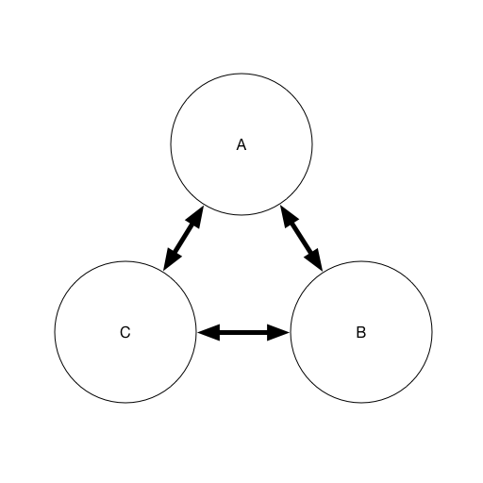

**b. directed graph**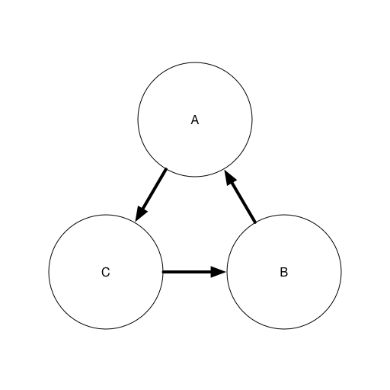

A **connected graph** has to have a **path** between every pair of vertices.

**\*Inter3* Draw a smallest connected graph with 3 vertices.**

**a. undirected graph**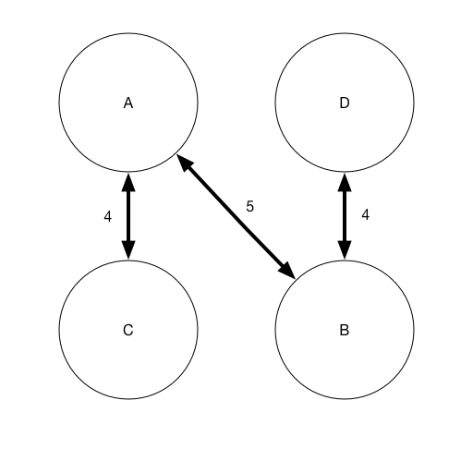

**b. directed graph**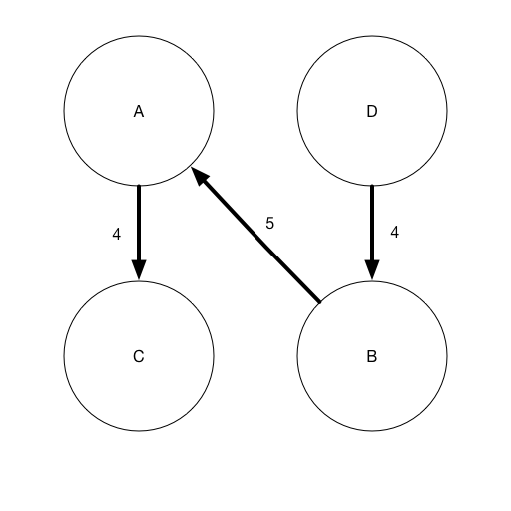

**\*Inter4* How many edges does a tree of N nodes have? Why?**

**N-1 Because every node has an edge coming in/out of it with the exception of the head node. (root node)**

**\*Inter6* If my directed graph has 200 cities, and I want to make sure there is a direct flight from any city to any other city, how many flights are needed?**

**If you are looking for a direct flight between any city to another city, you would only need 1 flight, or else it is not direct.**

**\*Inter7* If my undirected graph has 200 cities, and I want to make sure I can drive from any city to any other city, how many road are needed?**

**N^2**

For an adjacency list representation:

**\*Inter12* If you have N vertices and M edges,**

**- how many array slots are there in G??**

**Assuming “G” is the G Table, we are looking at N vertices-leading to N slots.**

**- how many linked list nodes are required altogether**

**for directed G? Why?**

**The quantity of linked list nodes is the sum of all vertices and each vertex’s list of nodes.**

**for undirected G? Why?**

**The quantity of linked list nodes is the sum of all vertices and each vertex’s list of nodes less the nodes that are already included in the table**

**Review Questions from Notes-11A:[10pts] Your score:**

**Depth First Traversal from the notes ends like this:**

Pop I. [F G top]

I has not been marked yet.

Mark I.

Adjacent vertices are A G and E.

push E push G push A [F G E G A top]

**\*Inter2* Complete this trace from this point using exactly the same wording and the same format until the stack becomes empty.**

Pop F [G E G A top]

F has not been marked yet.

Mark F

Adjacent vertices are E and I

push E push I [G E G A E I top]

Pop G [E G A E I top]

G has been marked

No adjacent vertices.

Pop E [G A E I top]

E has not been marked yet

Mark E

No adjacent vertices

Pop G

G has been marked.

Go to next element [A E I top]

Pop A

A has been marked

Go to next element [E I top]

Pop E

E has been marked

Go to next element [I top]

Pop I

I has been marked

Go to next element [top]

Array is empty

**\*Inter3* On the graph you drew in Inter1, number the vertices**

**in the order they are marked by DFS**

**(i.e. A is 1, B is 2, etc.)**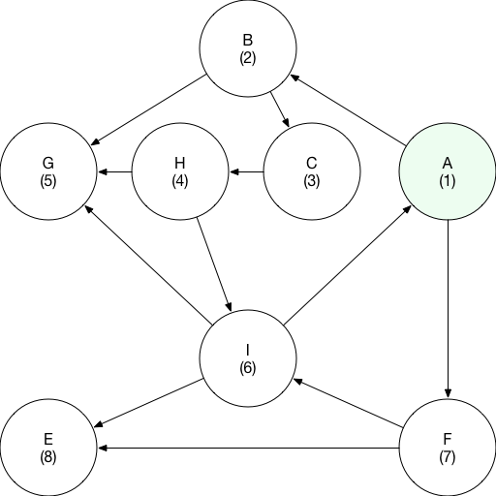

**Program Graph Implementation:[20pts] Your score:**

**dgraph.h, dgraph.C (see HW6help first)**

Create a **directed graph** **class** which has the following data member:

**I provided for you HW3 files in case your HW3 is not working.**

**Gtable[20]**(an array) which contains the following (struct)in each slot:

**Struct Gvertex: (this is declared outside the class)**

- a vertex name (char)

- the mark/visit number (int)

- the out degree (int)

- a linked list object for adjacent vertices**(from HW3P3 slist but with char element type)**

You may use other data members such as size (how many slots are used) as necessary.

**And the following methods/member functions:**

dgraph Constructor - initializes the table entries

[ Make sure the names are initialized to be ‘ ‘ and visit number is 0]

dgraph Destructor - destroys the table

[ Does this call the list destructor automatically? If not, you have to destroy the lists. Test and see. ]

displayGraph() – displays the table content in a very readable format

But make sure you do not display unused slots

fillTable() - reads the input file **table.txt** to fill the table

Open and close the input file table.txt in here

int findOutDegree(char) – returns the out degree of the vertex

whose name is given as an argument

slist findAdjacency(char) – returns the linked list of

adjacent vertices of

the vertex whose name is given as an argument

[ This one calls your HW3P3 copy constructor automatically because a list is being returned.]

**Note that the mark/visit number is not being used yet by these functions. It will be used in the next HW.**

**Note that the linked list of adjacent vertices is of type slist and thus, you can use any of the slist member functions on it.**

**table.txt** should have the following format:

Each line is

name out-degree a-list-of-its-adjacent-vertices-separated-by-blanks

e.g.

A 2 B F

**I have provided you with the input file based on Notes-11A.doc**.

**Write a client program which will:**

1. fillTable()
2. displayGraph()
3. findOutDegree(char) for various vertices in the graph (a loop)
   1. the user will specify which vertex
   2. displays the returned result
4. findAdjacency(char) for various vertices in the graph (a loop)
   1. the user will specify which vertex
   2. displays the returned list (use HW3P3 function)

**Q) The state of the program statement [2pts]**

* **Does your program compile without errors?**
  1. **Not that I am aware of. Works on Xcode**
* **List any bugs you are aware of, or state “No bugs”:**
  1. **No bugs. But, could not test on Empress due to following error(s):**
     1. **Could not connect to Empress. I tried on multiple machines with different connections**
     2. **Could not connect to Empress in FilePutty. Would connect me to the server but would kick me out before it is able to log me on. credentials are correct, I am sometimes able to make it into putty, but without my files transferred over, I cant test anything.** 
        1. **For my files, I uploaded to cloud service and downloaded onto the remote machine. The directory was different and I was not able to access my cs311files folder.**

**Submit these files:**

1. **This assignment sheet with your answers**
2. **dgraph.h**
3. **dgraph.C**
4. **client.C**
5. **table.txt that I have provided**
6. **the r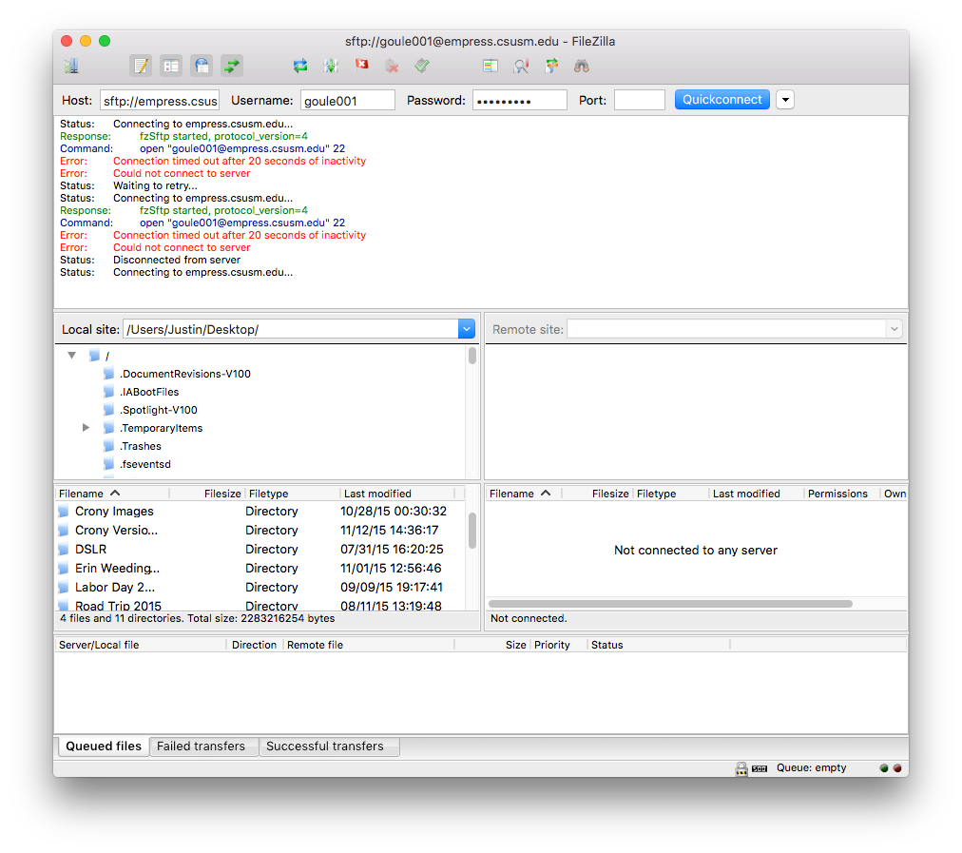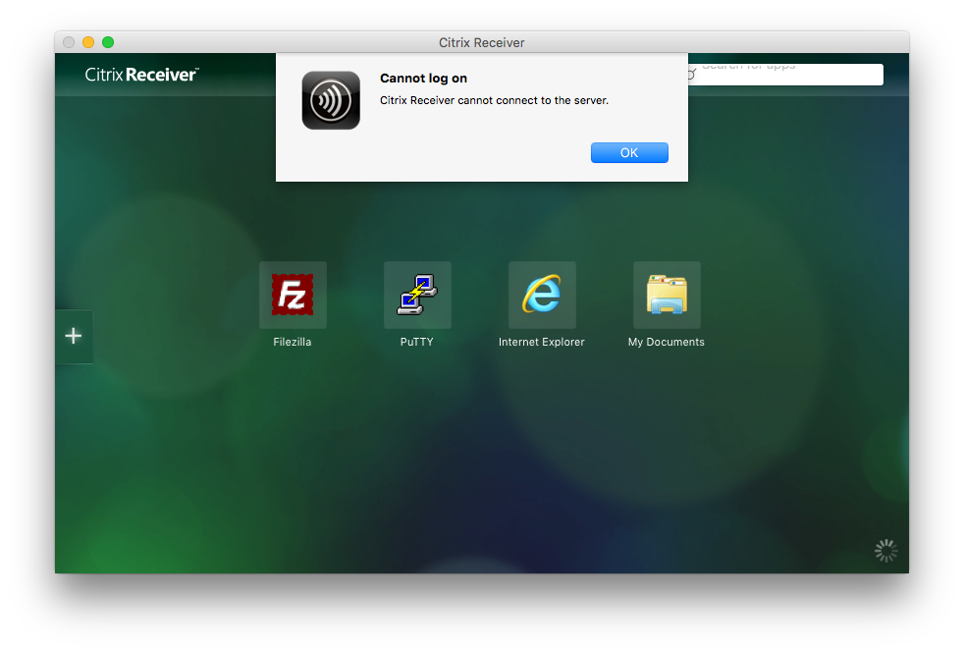esults of thorough test cases (screen dump or script)**

**Whether working or not, test result must include the lines for compiling your files or we will not grade your program i.e. 0 points for the program.**

**Did you check your comments and style against CS311 How To Comment.doc??**